AIMS GRID:

1. Purpose (why are we doing this project and what we aim to achieve)
2. Stakeholders (who all will be involved in the project)
3. End-result (what we want to achieve as the result of the project)
4. Success criteria (measures to check extent of success)

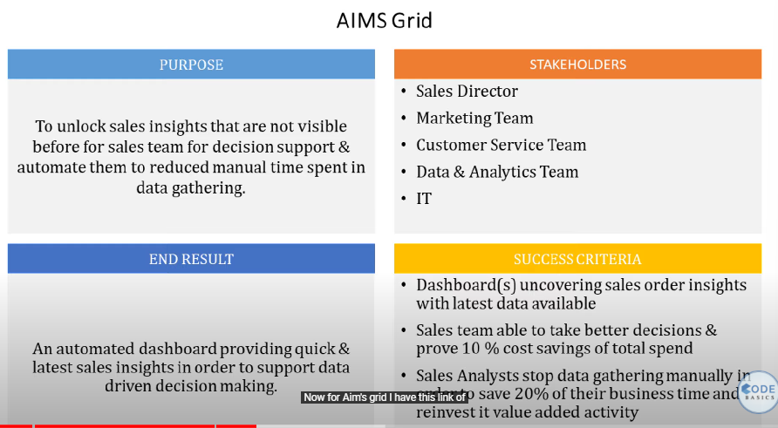

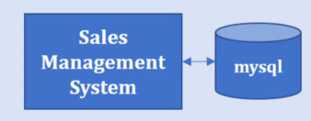 Built by the in-house IT team to keep track of the products sold by the company and of the details of each transaction.

Data analyst team can directly hook tableau with the mySQL database and do their analysis and build the dashboard.

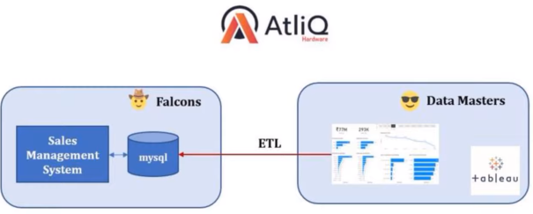

Big companies with large-scale projects have these data warehouses that take the data from mySQL using ETL (Extract – Transform – Load) to transform the raw data in a different format. This is done by the data engineers team

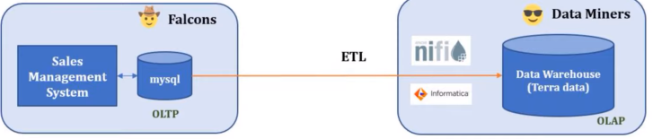

MYSQL and Sales Management System are part of OLTP (online transaction processing system) in which daily sales are recorded.

If the data analysis process is carried out directly on MySQL, then the database functions might get slower affecting the business.

To avoid this the companies, use data warehouses called OLAP (Online Analytical Processing System).

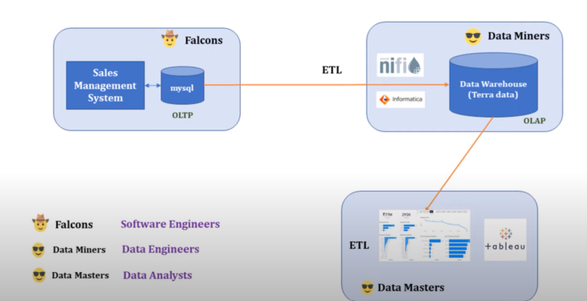

In this project, we will not use a data warehouse and directly hook up to MySQL.

PROCEDURE:

* connect the MySQL database with Tableau.
* Create a data model that connects the different data tables and establishes the relationship between those tables.
* It is also called STAR SCHEMA. In the centre, we have the FACT TABLE (in this case transaction table); the remaining tables are called DIMENSIONAL TABLES.

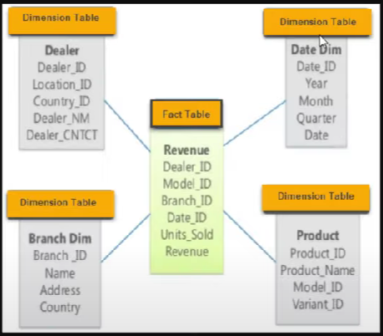

* Drag and drop the transactions table in the workspace. Then drag the other dimension tables and establish the relationships with fields that are common in both the dimension and fact tables.
* Sort the sales amount column in the transactions table. You will notice that some rows have values -1 and 0. We cannot sell anything for -1 and the amount being 0 means the product is given for free which shouldn’t be the case in the sales table (assuming the minimum amount of Rs.1 for selling).
* Therefore, go to Data (Top left) > Edit data source filters > choose the column amount > type of filter.
* In the markets table, the New York and Paris transactions have null values in the zone column. Let us assume we want to remove them.
* Go to Data (Top left) > Edit data source filters > Choose the column Markets code > Select all codes except 097 and 999.
* There are a few transactions in USD. Therefore, we convert them to INR.
* Click on the small arrow above the sales amount field >> create a calculated field called Normalized amount >> set up a formula (IF [Currency] = ‘USD’ THEN [Sales amount] \*74 else [Sales amount] END
* In real-life projects, we will retrieve the conversion values using an API.